Are You Ready For Voice-Activated TV?
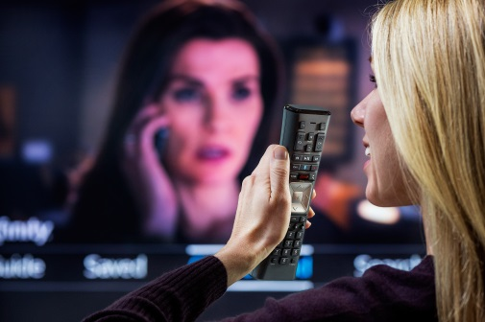
Voice activation’s significance is reflected in the rapid adoption rate for the technology — by the end of this holiday season, 50% percent of all U.S. consumers will own a smart speaker. What’s important for television are predictions that, in the next two years, voice assistants will move from their current role, one in which they simply provide streamed audio, to one that includes providing video access.
TVNewsCheck 12.14.18
https://tvnewscheck.com/article/top-news/226923/ready-voice-activated-tv/?utm_source=Listrak&utm_medium=Email&utm_term=Are+You+Ready+For+Voice-Activated+TV%3f&utm_campaign=Nexstar+Settles+DOJ+Ad+Info+Investigation
Image credit:
https://corporate.comcast.com/images/Voice-Remote-Customer.jpg

