Artists Could Opt Out of Radio Play Under PROMOTE Legislation
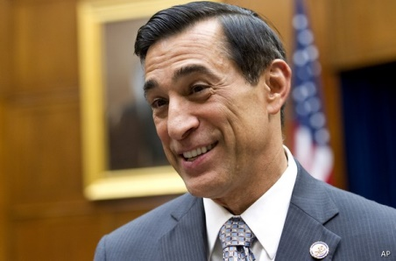
Reps. Darrell Issa, R-Calif., and Ted Deutch, D-Fla., introduced legislation that would allow artists to pull their music from radio stations if they do not receive an agreed-upon royalty rate. The National Association of Broadcasters’ Dennis Wharton said the group is concerned that the legislation "would upend the music licensing framework that currently enables broadcasters to serve local communities across the country."
Radio Ink 4/5/17
http://radioink.com/2017/04/05/radio-war-record-labels-coming/

