AM-FM Act Finds Little Support in House, Senate
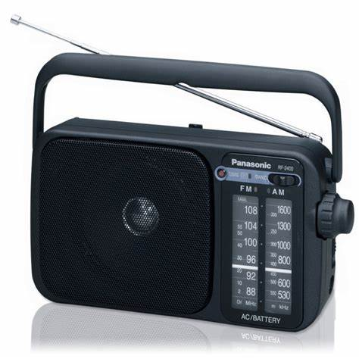
The Ask Musicians for Music Act, a bill that would impose a performance royalty on broadcast radio for music airplay, has yet to add any cosponsors since its introduction in Congress a little over a month ago.
Inside Radio (free content) 1/3/20
http://www.insideradio.com/free/little-support-for-radio-royalty-bill-as-backers-fail-to/article_1b60f42e-2df2-11ea-ba58-c7ccd28c9800.html
Image credit:
https://www.bing.com/images/search?view=detailV2&ccid=ziSZvlFv&id=5F6E040FAA7BF38EA390E797E0992322B34624A0&thid=OIP.ziSZvlFvxPFcwy4CiG3F1AHaHa&mediaurl=http%3a%2f%2fs3.euronics.ee%2fUserFiles%2fProducts%2fImages%2f23200_1.jpg&exph=880&expw=880&q=AM+FM+radio+act&simid=608027640274095065&selectedIndex=58&ajaxhist=0

