Atlantic Broadband to Acquire MetroCast in $1.4B Beal
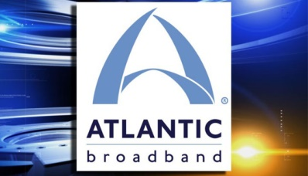
Cogeco Communications subsidiary Atlantic Broadband on Monday announced that it will acquire Harron Communications' MetroCast Cablevision in a $1.4 billion deal. The deal, which is expected to close as early as January, will expand Atlantic Broadband's footprint by more than 236,000 homes across five states.
Bloomberg 7/10/17
https://www.bloomberg.com/news/articles/2017-07-10/cogeco-agrees-to-buy-metrocast-from-harron-for-1-4-billion

