AT&T Details $2B Investment In Broadband Access
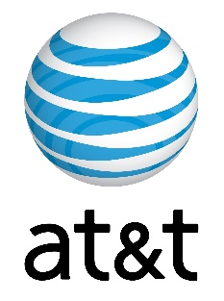
AT&T's three-year broadband access investment, which the carrier notes is worth $2 billion, includes 20 centers for connected learning in neighborhoods where residents often lack broadband. The locations will feature high-speed AT&T Fiber internet and Wi-Fi connectivity, as well as access to tablets and laptops.
FierceTelecom 4.14.21
https://www.fiercetelecom.com/operators/at-t-will-pump-2b-funds-toward-closing-digital-divide

