AT&T Takes 5G Live in 12 Cities
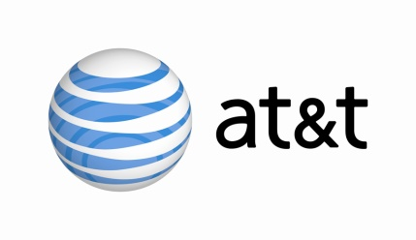
AT&T has turned on its 5G network in selected parts of 12 markets and on Friday will introduce its first device that can support the network, Netgear's Nighthawk 5G Mobile Hotspot. The device, which is linked via millimeter-wave spectrum, will cost $499, and the service will begin at $70 a month.
VentureBeat 12/18/18
https://venturebeat.com/2018/12/18/att-opens-5g-network-in-12-u-s-cities-announces-pricing-for-first-5g-mobile-device-and-service/

