AT&T Could Try to Broaden Its Sports-Rights Portfolio
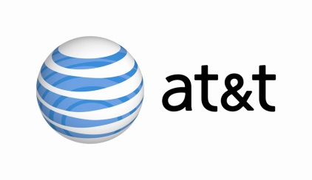
Many traditional and digital media companies are focused on the next cycle of rights to broadcast NFL football, which will start to come up for renewal, first at ESPN in 2021 and at NBC, CBS and Fox the following year. Might AT&T be interested? “We are not going to take anything off the table,” says Jeff Zucker.
Variety 3.4.19
https://deadline.com/2019/03/viacom-closes-340m-pickup-of-pluto-tv-1202568860/

