AT&T’s WarnerMedia And Discovery To Merge
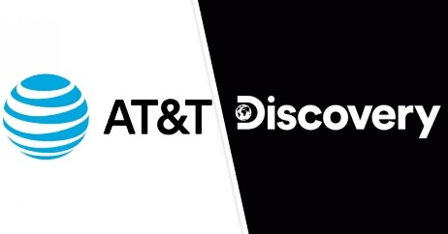
The partners said the new company will compete globally in the fast-growing direct-to-consumer business, bringing compelling content to DTC subscribers across its portfolio, including HBO Max and the recently launched discovery+. It will combine WarnerMedia’s storied content library of popular and valuable IP with Discovery’s global footprint, trove of local-language content and deep regional expertise across more than 200 countries and territories.
Deadline Hollywood 5.17.21
https://deadline.com/2021/05/att-discovery-merge-entertainment-assets-create-new-company-1234758218/

