AT&T Completes Spinoff Of DIRECTV
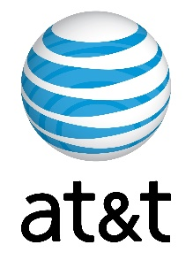
DIRECTV is now an independent company, as AT&T has completed a spinoff that also includes U-Verse and AT&T TV, and plans to offer AT&T's former streaming services under DIRECTV Stream. The new platform will apparently be available through both streaming devices and satellite links.
Next TV/Broadcasting+Cable 8.2.21
https://www.nexttv.com/news/directv-stream-becomes-single-brand-for-former-atandt-video-services

