AT&T to Purchase Time Warner in $85.4B Deal
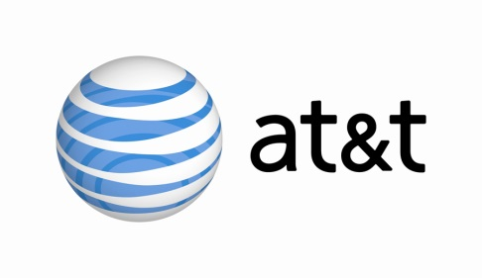
AT&T on Saturday announced that it has made a deal to purchase Time Warner for $85.4 billion, or $107.50 per share. The merged business -- which will combine AT&T's TV and wireless business with Time Warner's premium content, including HBO and CNN -- would be headed by AT&T CEO Randall Stephenson.
The New York Times 10/22/16
http://www.nytimes.com/2016/10/23/business/dealbook/regulatory-microscope-lies-ahead-for-att-and-time-warner.html?_r=1&WT.mc_id=SmartBriefs-Newsletter&WT.mc_ev=click&ad-keywords=smartbriefsnl

