AT&T Plans to Add DIRECTV to Connected Cars
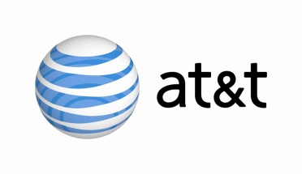
AT&T is working to bring its DIRECTV service to vehicles via a cellular network, although the telecom has yet to set a timeline for the integration, Senior Vice President Chris Penrose said. The company recently unveiled a data program for connected cars, offering service for $40 per month.
The Washington Post 5/25/16
https://www.washingtonpost.com/news/the-switch/wp/2016/05/25/att-wants-to-pipe-directv-straight-into-your-car/

