Audacy Launches 2 Stations With Sports Betting Focus
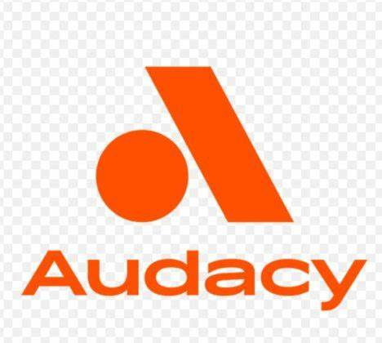
Audacy stations in Memphis, Tenn. and Rochester, N.Y., have begun carrying sports betting content from BetQL Network as well as programming from CBS Sports Radio. Rochester's WROC-FM/AM has broken off its relationship with ESPN and become 95.7 The Fan during the format change.
Radio Ink 12/9/21
https://radioink.com/2021/12/09/audacy-fully-embracing-sports-gambling/

