AURN Extends Gaming Presence With Tournament
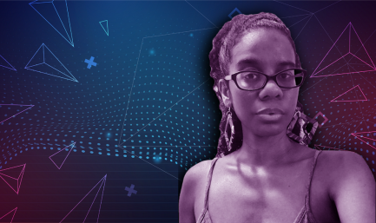
American Urban Radio Networks has picked some of the most popular Black gamers for its Oct. 14-16 AURN Gaming Tournament. The organization is also teaming up with HipHopGamer on a daily audio program and is planning a streaming series featuring gaming content on YouTube and Twitch.
Inside Radio (free content) 10/14/22
https://www2.smartbrief.com/redirect.action?link=https%3A%2F%2Fwww.insideradio.com%2Ffree%2Faurn-isn-t-playing-around-with-new-effort-to-tap-into-growing-gaming-business%2Farticle_a62a5066-4b8e-11ed-a09d-a7507216485c.html&encoded=pCuaDwljfllFlqkIaAcekIalgpWL
Image credit:
https://aurn.com/wp-content/uploads/2021/01/4.png

