Azteca America Expands With WGEN Miami
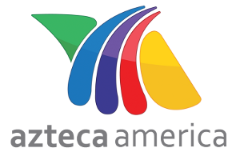
The Spanish-language network signs an affiliation and sales agreement with WGEN in the nation’s third-largest Hispanic market. The addition expands Azteca America's network to 65 markets.
TV NewsCheck 11.28.16
http://www.tvnewscheck.com/article/99569/azteca-america-expands-with-wgen-miami?utm_source=Listrak&utm_medium=Email&utm_term=Azteca+America+Expands+With+WGEN+Miami&utm_campaign=DirecTV+Now+Launching+With+3+Of+Big+4

