"Baby, It's Cold Outside" Controversy Shows Listener Power
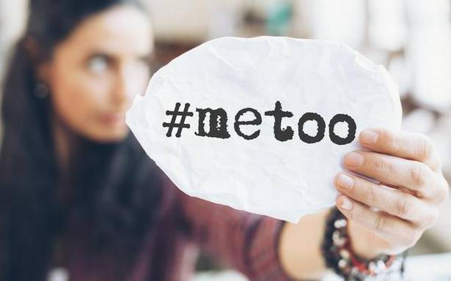
Several radio stations across the country have either pulled or lowered the rotation play of "Baby, It's Cold Outside" because of the controversy, amid the #MeToo movement, that the classic song has generated. KOIT's program director, Brian Figula, has reached out to listeners on both sides of the debate, which highlights the power listeners have to influence radio.
CNN 12/7/18
https://www.cnn.com/2018/12/07/entertainment/radio-baby-its-cold-outside/index.html?utm_source=CNN+Media%3A+Reliable+Sources&utm_campaign=38b853467b-EMAIL_CAMPAIGN_2018_09_11_04_47_COPY_01&utm_medium=email&utm_term=0_e95cdc16a9-38b853467b-81559621
Image credit:
https://www.thehindu.com/sci-tech/technology/internet/article19876035.ece/ALTERNATES/LANDSCAPE_615/metoo

