BBC America, Women's Media Center Form "Strategic Alliance"
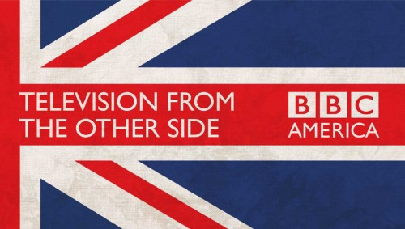
BBC America and Women's Media Center have teamed up to increase women's representation on screen through a newly formed "strategic alliance." The alliance is already planning to release a study about the effect onscreen portrayals of women have on girls and young women, and is promoting BBC America's "Galaxy of Women" campaign, which spotlights shows like "Killing Eve," "Orphan Black" and "Doctor Who." "Representation matters: If you can't see her, you can't be her," BBC America President and GM Sarah Barnett said.
Syfy Wire 8/29/18
https://www.syfy.com/syfywire/bbc-america-and-womens-media-center-want-to-increase-onscreen-representation-of-women

