BBC License Fee To Be Abolished In 2027 And Funding Frozen
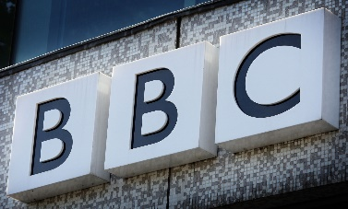
The BBC will have to make deep cuts to its programme budgets after the government said the broadcaster’s funding would be frozen for the next two years, with the license fee abolished completely in 2027. Culture secretary, Nadine Dorries, said this would be the end of the current license fee funding model for the BBC, raising doubts about the long-term financial future and editorial independence of the public service broadcaster under a Conservative government.
The Guardian 1.16.22
https://www.theguardian.com/media/2022/jan/16/bbc-licence-fee-to-be-abolished-in-2027-and-funding-frozen

