'BBC World News' Posting Audience Records
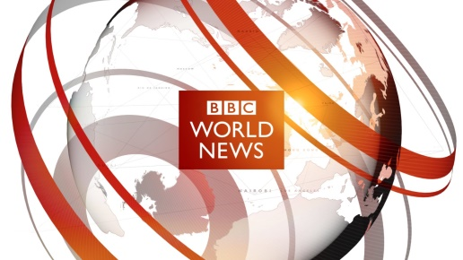
One of the world’s largest media companies is riding high in 2017. The BBC is currently reaching a record weekly audience of 372 million around the globe. That’s a 7% rise from the previous year.
TVNewser 5.26.17
http://www.adweek.com/tvnewser/bbc-world-news-is-posting-weekly-global-audience-records/330351

