Belarus Accused Of ‘Hijacking’ Ryanair Flight To Arrest Blogger
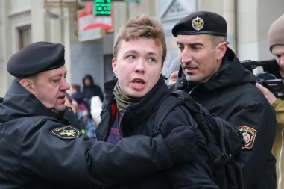
Roman Protasevich, a former editor of the influential Telegram channels Nexta and Nexta Live, was detained by police after his flight was diverted to Minsk national airport. Minsk confirmed that Lukashenko ordered his military to scramble a Mig-29 fighter to escort the plane.
The Guardian 5.23.21
https://www.theguardian.com/world/2021/may/23/belarus-diverts-ryanair-plane-to-arrest-blogger-says-opposition
Image credit:
http://intpolicydigest.org/wp-content/uploads/2021/05/6083401026319.jpg

