Best of Journalism Honored at Murrow Awards
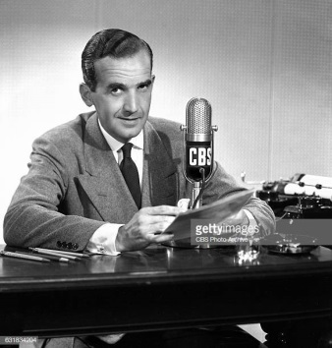
The Radio Television Digital News Association has been honoring outstanding achievements in electronic journalism with the Edward R. Murrow Awards since 1971. Award recipients demonstrate the spirit of excellence that Murrow set as a standard for the profession of electronic journalism.
RTDNA 10.15.19
https://www.rtdna.org/content/2019_national_edward_r_murrow_award_winners?utm_source=CNN+Media%3A+Reliable+Sources&utm_campaign=1b971b3c45-EMAIL_CAMPAIGN_2018_09_11_04_47_COPY_01&utm_medium=email&utm_term=0_e95cdc16a9-1b971b3c45-82227929&utm_source=Listrak&utm_medium=Email&utm_term=Best+Of+Journalism+Honored+At+Murrow+Awards&utm_campaign=Sanders%3a+Break+Up+Big+Cos.+Like+Disney%2fFox
Image credit:
http://media.gettyimages.com/photos/portrait-of-cbs-news-correspondent-edward-r-murrow-new-york-ny-image-picture-id631834204?s=612x612

