Biden Adds Billions For Broadband In 2023 Budget
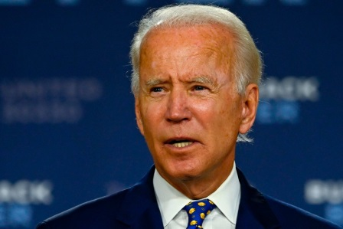
President Joe Biden has proposed adding $600 million to the USDA's ReConnect program, which provides loans and grants for expanding broadband access, as part of his 2023 budget. The plan also allocates a total of $40 billion to the USDA and Commerce Department for discretionary broadband spending.
Next TV/Multichannel News 3/28/22
https://www.nexttv.com/news/biden-budget-has-even-more-bucks-for-broadband
Image credit:
https://nypost.com/wp-content/uploads/sites/2/2020/08/joe-biden-6.jpg?quality=90&strip=all&w=1200

