Big Brands Turn to More Authentic Influencers
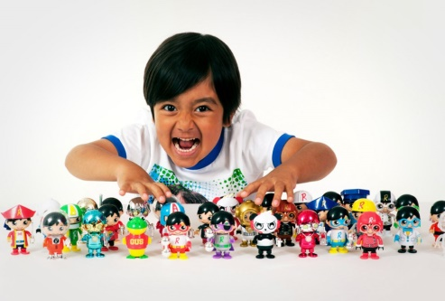
Walmart is collaborating with 6-year-old YouTube sensation Ryan, Nordstrom is partnering with lifestyle influencer Arielle Charnas and Target is seeking clothing design inspiration from Gen Z influencers -- all indicative of the fact that big retailers are embracing a new style of influencer marketing, writes Charisse Jones.
USA Today 8/6/18
https://www.usatoday.com/story/money/2018/08/06/social-media-influencers-ocial-media-influencers/725842002/
Image credit:
https://www.altonivel.com.mx/wp-content/uploads/2018/07/30145639/Ryan-Walmart.jpg

