Cable, Streaming Nets Share $1B Big Ten Sports Rights Deal
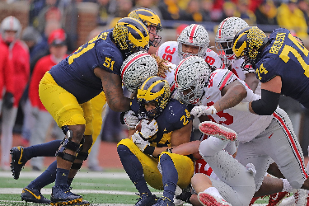
Broadcast, cable and streaming networks owned by Fox, NBC and CBS will air Big Ten college football and basketball games under a new seven-year, $1 billion agreement that starts in 2023. Games will appear on Fox's Big Ten Network and Fox Sports 1 with others streaming on NBCUniversal's Peacock and CBS' Paramount+.
The Hollywood Reporter 8/18/22
https://www.hollywoodreporter.com/tv/tv-news/big-ten-games-tv-streaming-deals-cbs-fox-nbc-1235201493/
Image credit:
https://cdn.vox-cdn.com/thumbor/nFhLQaWZzPMhsv5QPvR7CFgu-uQ=/0x0:3000x2058/2420x1613/filters:focal(1260x789:1740x1269)/cdn.vox-cdn.com/uploads/chorus_image/image/67144947/1191278312.jpg.0.jpg

