“Big Three” Music Labels, Recording Academy Commit to Ending Systemic Bias In the Music Industry
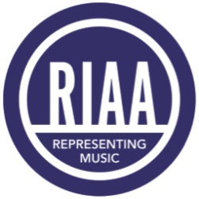
The Recording Academy, Universal Music Group, Sony Music Group and Warner Music Group recently issued a statement regarding their commitment to racial equity and ending a culture of systemic bias in the music industry. The commitment comes as a result of ongoing dialogues with DEI executives in the industry.
Billboard 12.21.20
https://www.billboard.com/articles/business/9503532/recording-academy-umg-sony-wmg-diversity-execs-racial-equity-statement

