Big Trend on Cable TV: The After-Show
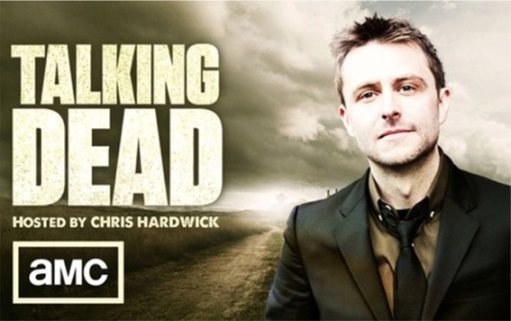
Instead of launching new scripted shows based on existing ones, cable has been launching after-shows. AMC rolled out “Talking Dead” in the fall of 2011, when “The Walking Dead” was building into a phenomenon. The past five years, it’s become one of the most popular shows on cable.
MediaLife 4.6.16
http://www.medialifemagazine.com/big-trend-on-cable-the-after-show/

