Bill Would Allow FTC To Fine Companies Over Privacy Violations
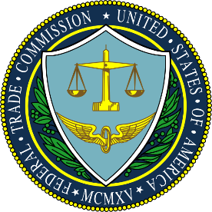
A bill introduced Friday would boost the Federal Trade Commission's authority by empowering the agency to fine companies the first time they commit an unfair or deceptive practice, and to issue regulations more easily.
Media Post 7.16.21
https://www.mediapost.com/publications/article/365155/bill-would-allow-ftc-to-fine-companies-over-privac.html?utm_source=Listrak&utm_medium=Email&utm_term=Bill+Would+Allow+FTC+To+Fine+Companies+Over+Privacy+Violations&utm_campaign=Top+Olympic+Sponsor+Toyota+Pulls+Games-Related+TV+Ads

