AT&T, Clear Channel Unite to Give Billboards Tracking Powers
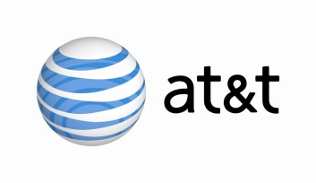
Clear Channel Outdoor Americas has teamed with AT&T to track consumer travel patterns and habits via mobile phones and billboards. The partnership means that advertisers could get analytics that tell them personal data about an individual who walks past a billboard and whether they then visit a store.
The New York Times 2/28/16
http://www.nytimes.com/2016/02/29/business/media/see-that-billboard-it-may-see-you-too.html?WT.mc_id=SmartBriefs-Newsletter&WT.mc_ev=click&ad-keywords=smartbriefsnl&_r=0

