Bing Trials Search Results that Add Chatbot Option
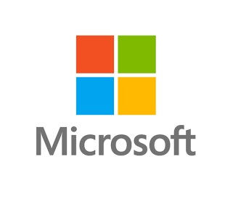
Microsoft's Bing search engine is trying out chatbot extensions. The search result for a certain restaurant, for example, may include a box that invites questions that can be answered by a bot.
The Drum (Scotland) 9/30/17
http://www.thedrum.com/news/2017/09/30/microsoft-introduces-chatbot-enable-advertisers-with-personalised-customer

