Coming, a Booming Year for Local Digital Radio
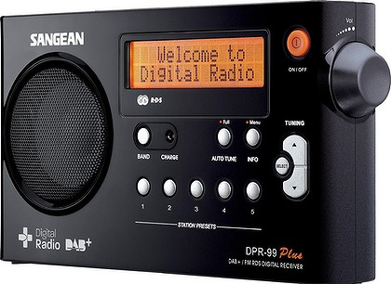
Local digital radio has been rising steadily for more than a decade. But 2017 will be a breakout year for the medium. Growth will accelerate to its fastest pace since 2012, and spending will hit an all-time high of $753 million. That’s according to a new report from Borrell Associates, in association with the Radio Advertising Bureau.
MediaLife 2.10.17
http://www.medialifemagazine.com/coming-booming-year-digital-radio/
Image credit:
http://www.darraghmurray.com/wp-content/uploads/digitalradio-420x0.jpg

