Boston Radio Station Raises $230K+ For Veterans
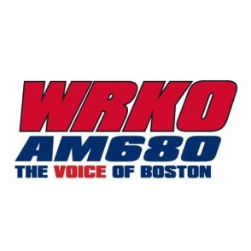
WRKO in Boston raised more than $230,000 for the Disabled American Veterans Department of Massachusetts during a radiothon on Nov. 8. The event started in 2016, and has given more than $600,000 to veterans in the three years it's been running.
Radio Ink 11/11/19
https://radioink.com/2019/11/11/230k-raised-by-radiothon-for-vets/

