Brand Response to Coronavirus Vital for Consumer Trust
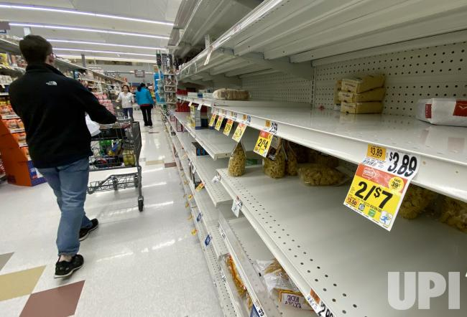
Some 90% of global consumers believe brands should protect their employees and suppliers, and tackle social struggles during the coronavirus pandemic, per the 2020 Edelman Trust Barometer. Additionally, 69% of US participants say a brand would lose their trust forever if they witness it valuing profits over people during the pandemic and 61% say a brand's response during the crisis will have a major effect on whether or not they'll purchase from it in the future.
MediaPost Communications 3.31.20
https://www.mediapost.com/publications/article/349262/consumers-see-existential-role-for-brands-say-the.html
Image credit:
https://cdnph.upi.com/pv/upi/e82d2d92a4bab4507a9878060fb419cc/MARYLAND-CORONAVIRUS-SHOPPING.jpg

