Brands Pay This Instagrammer $15,000
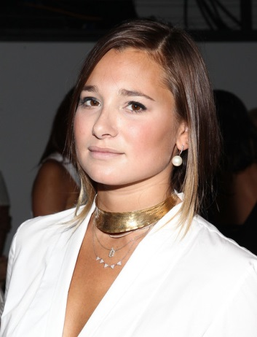
Brands pay some Instagram users to include products in their pictures. It's among the latest frontiers in sponsored content. And one of these lucky Instagrammers, Danielle Bernstein, who runs the style blog and Instagram feed We Wore What, tells Harper's Bazaar that she makes mid-six figures a year doing this.
Advertising Age 5.20.15
http://adage.com/article/digital/brands-pay-instagrammer-15-000-include-products-a-picture/298709/?utm_source=daily_email&utm_medium=newsletter&utm_campaign=adage&ttl=1432930329

