New Jersey Earmarks $70M From CPF To Boost Broadband
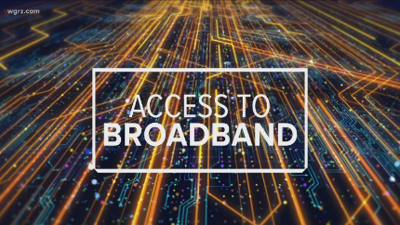
New Jersey will use $50 million from federal Capital Project Funds on broadband projects in underserved or unserved areas. Another $15 million goes to provide free broadband on public buses and the state is spending the remaining $5 million on simplifying access to state agencies.
Telecompetitor 3.18.24
https://www.telecompetitor.com/new-jersey-to-use-70m-in-cpf-funds-for-broadband/
Image copyright:
https://www.columbiaedc.com/wp-content/uploads/2021/07/Broadband_FairUse-768x432.jpg

