Average Broadband Was 44% Faster This Year
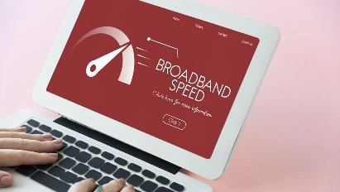
Broadband across the US got 44% speedier on average this year. HighSpeedInternet.com, which conducted the study, found that Connecticut, New Jersey and Florida offered the zippiest service.
Telecompetitor 11.16.23
https://www.telecompetitor.com/report-national-average-internet-speed-up-44/
Image credit:
https://cdn.mos.cms.futurecdn.net/ManZWXaSHVaqqNjRCVFNwd-1200-80.jpg

