Broadcasters Boost Fact Checking Ahead of Election
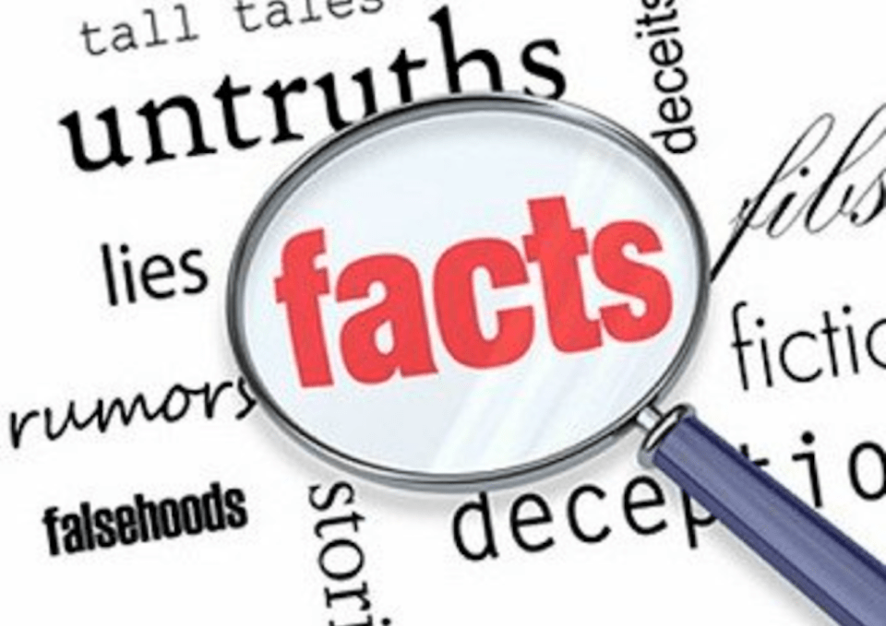
A growing number of television broadcasters are teaming with external fact-checking agencies to ensure the accuracy and reliability of their news coverage in the final two months of the 2020 presidential election campaigns. Journalists at CBS, E.W. Scripps, Graham Media, Hearst and Tegna are undergoing special training and working with experts in an effort to maintain viewers' trust.
TVNewsCheck (free registration) 9/8/20
https://tvnewscheck.com/article/top-news/253233/as-election-nears-tvs-fact-checking-surges/
Image credit:
https://i1.wp.com/opinion.premiumtimesng.com/wp-content/files/sites/2/2018/07/Fact-Checking-News.png?fit=960%2C679&ssl=1

