Broadcasters Team Up for Hurricane Florence Coverage
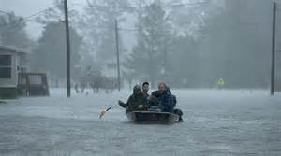
Local radio stations and groups have been finalizing their preparations for Hurricane Florence by preparing infrastructure and staff for its impact. Groups such as Beasley and Community Broadcasters have plans in place to switch to wall-to-wall coverage if necessary, while TV and radio groups are putting competition aside and partnering to provide the most resources and real-time information for listeners.
Inside Radio 9/14/18
http://www.insideradio.com/free/florence-roundup-radio-rises-to-the-challenge/article_44842d3a-b7f1-11e8-9b78-431026cfc61c.html
Image credit:
https://www.bing.com/images/search?view=detailV2&ccid=XuKL0Fdu&id=FA9709637869355DE6B21AC0524D7B74C0429BB5&thid=OIF.r%2bvVSDrNyoWNSd%2bW53Y7%2fQ&mediaurl=https%3a%2f%2fwww.thestatesman.com%2fwp-content%2fuploads%2f2018%2f09%2fHurricane-Florence.jpg&exph=669&expw=1200&q=hurricane+florence&simid=227406004365&selectedIndex=1&ajaxhist=0

