Broadcasters Worry About Sports Uncertainty
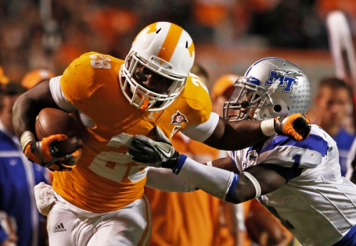
Television networks have spent millions on the rights to sporting events that are now on hold indefinitely, but have yet to announce whether or not they will seek to recoup the money they're out. Some media officials have raised concerns that the funds tied up in sports deals might be needed if governments ask pay-TV companies to reduce bills for consumers.
CNBC 4/1/20
https://www.cnbc.com/2020/04/01/coronavirus-sports-cancellations-set-up-media-fights-over-refunds.html
Image credit:
https://1.bp.blogspot.com/-f3euKtH9FCM/Tr1lPeOI0pI/AAAAAAAAAtM/dYdVAOtrBrE/s1600/TNLH106.jpg

