Bud Light Creates Fridge That Alerts When the Beer is Low
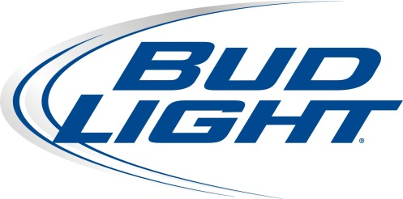
The WiFi-connected refrigerator has a digital counter on the outside showing the number of beers inside. The information is also displayed on an app available for Apple and Android devices. Both the app and fridge include a countdown timer showing how long until the beer inside reaches its "optimal serving temperature" of below 32 degrees "without freezing them," according to the Anheuser-Busch InBev-owned brand.
Advertising Age 10.5.15

http://adage.com/article/digital/bud-light-creates-a-fridge-alerts-beer-low/300744/?utm_source=daily_email&utm_medium=newsletter&utm_campaign=adage&ttl=1444623858

