Buffalo AM Provides Ongoing Coverage Of Snowstorm
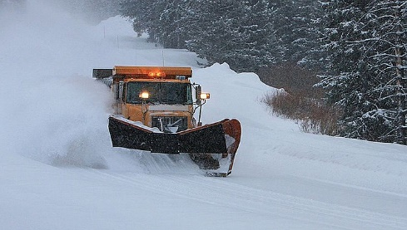
Audacy's WBEN 930-AM in Buffalo, N.Y., shifted its broadcast starting Friday to provide local listeners with continuous coverage of a storm that has left some regions buried under a significant snowfall. The station, which is using both broadcast and digital streams to keep audiences informed, has also covered the decision to relocate a Buffalo Bills game to Detroit because of the storm.
Inside Radio (free content) 11.18.22
https://www.insideradio.com/free/wben-in-wall-to-wall-storm-coverage-as-snow-cripples-parts-of-buffalo/article_5ae9f7ac-6789-11ed-9ff3-bf0670dbc5e3.html
Image credit:
https://westernnews.media.clients.ellingtoncms.com/img/photos/2022/11/19/massive_snow_storm_web_5_t715.jpg?529764a1de2bdd0f74a9fb4f856b01a9d617b3e9

