Build Brand Identity Via Digital Content
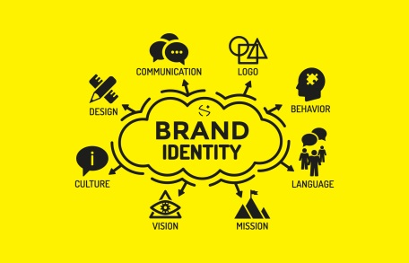
Marketers should create their digital content with consistent messaging and design that reflects their brand identity and ethos, writes Matt Faulk. Create in-person experiences and work with local communities that share your brand's values to encourage user-generated content that reflects authenticity on social media, he writes.
SmartBrief/Marketing 9/13/18
http://smartbrief.com/original/2018/09/how-embrace-brand-culture-through-digital-experiences?utm_source=brief
Image credit:
https://www.backdesk.ng/blog/wp-content/uploads/2017/07/brand-identity-system.jpg

