Building Community via Influencer Marketing
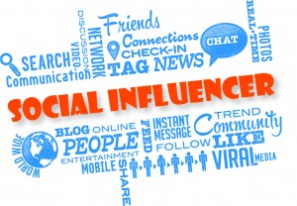
When it comes to adopting a new form of communication, not only do consumers have to buy in, but so do their personal networks, otherwise users -- and the app builders -- will only find silence on the other end of the line.
Advertising Age 9.20.16
http://adage.com/article/cmo-strategy-columns/building-community-influencer-marketing/305924/?utm_source=mediaworks&utm_medium=newsletter&utm_campaign=adage&ttl=1475095238?utm_visit=113450
image source:
https://www.bing.com/images/search?q=influencer+marketing&view=detailv2&&id=2481F8FEA46E6E83027E60CB3106EC3EDEEC1A2E&selectedIndex=20&ccid=sNNUpm8O&simid=608035390220077575&thid=OIP.Mb0d354a66f0ec7393108432cc97b9fe4o0&ajaxhist=0

