Building Shareable Content for PR
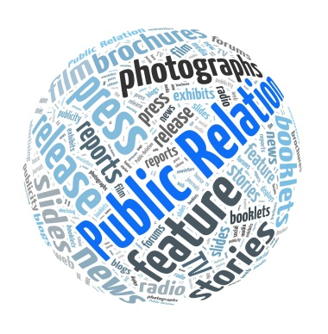
Using eye-catching visuals is increasingly essential to a successful PR campaign, Gini Dietrich writes. When designing a campaign, be sure to devote a good amount of time to planning distribution that will match the needs of the projects, she advises.
PRSAY 12/13/16
https://prsay.prsa.org/2016/12/13/go-beyond-the-news-release/
Image source:
https://publicrelationssydney.com.au/wp-content/uploads/2013/01/Public-relations-word-ball.jpg

