Buyers: More C7 Deals Are On The Way
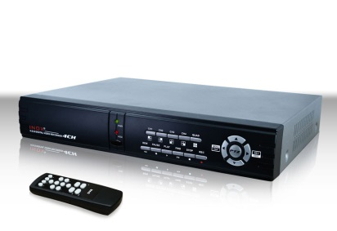
Buyers tell Media Life there will be even more deals made based on C7 in this year’s upfront, when the broadcast networks sell time for the upcoming TV season. But they caution that C7 will not become currency for most deals this year.
MediaLife 5.27.15

http://www.medialifemagazine.com/buyers-more-c7-deals-are-on-the-way/

