Byron Allen Challenges Madison Avenue to Spend With Black-Owned Media
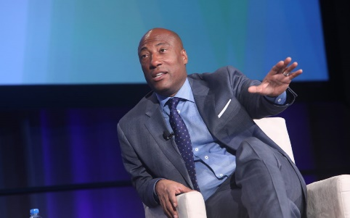
Allen “says he has engaged in conversations with chairpeople and CEOs at agencies and holding companies as well as brands about investing more in Black-owned media. But one year later, Allen says he has not seen any real progress.” Diversity efforts, he adds, usually focus on businesses owned by women, and he blames “the racism on Madison Avenue” for the perpetual lack of improvement.
AdAge 3.16.21
https://adage.com/article/media/byron-allen-challenges-madison-avenue-spend-black-owned-media-or-else-tuesday-wake-call/2322001?utm_source=ad-age-wake-up-call-tuesday&utm_medium=email&utm_campaign=20210315&utm_content=hero-headline&utm_source=Listrak&utm_medium=Email&utm_term=Byron+Allen+Challenges+Madison+Avenue+To+Spend+With+Black-Owned+Media%2c+Or+Else&utm_campaign=CBC+Animates+News+With+Graphics-Driven+Stories
Image credit:
https://a9p9n2x2.stackpathcdn.com/wp-content/blogs.dir/1/files/2019/09/4H3A0969-1080x675.jpg

