Analyst Calls Allen's Paramount Offer "Credible"
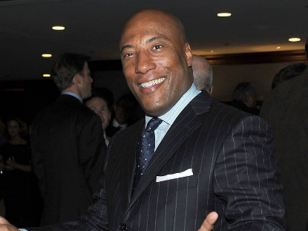
Byron Allen's proposal to pay $30 billion for Paramount Global is a "credible" bid and boosts the chances that Paramount will complete a deal with one of the parties that recently expressed interest, said Steven Cahall, an analyst at Wells Fargo. Allen confirmed the offer and said that Allen Media Group plans to purchase additional cable networks.
The Hollywood Reporter 1.31.24
https://www.hollywoodreporter.com/business/business-news/byron-allen-paramount-offer-is-it-real-wall-street-reaction-1235811704/
Image copyright:
https://wealthyspy.com/wp-content/uploads/2021/07/Byron-Allen-1.jpg

