Cable Consolidation Has Led to Higher Bills, Poor Service
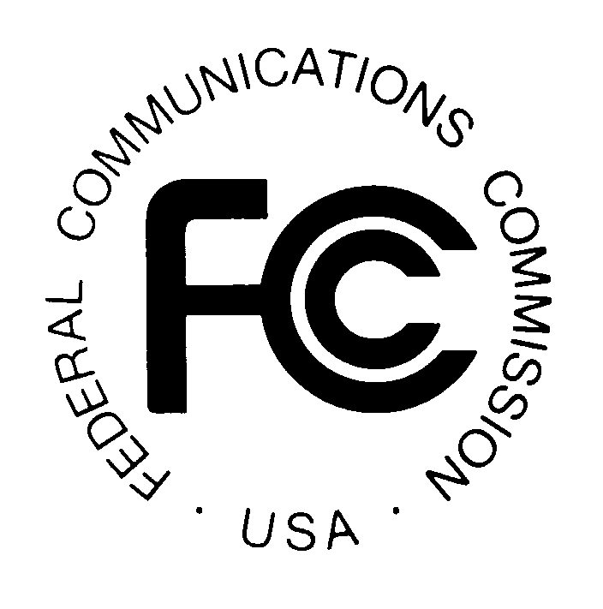
Sens. Bernie Sanders (I-Vt.) and Elizabeth Warren (D-Mass.) sent a letter to the FCC on Friday accusing big cable companies of using monopoly powers to muscle consumers into paying higher prices. Sanders and Warren wrote that mega-mergers have left over 60 percent of Americans with no choice whatsoever when it comes to their cable and Internet providers.
Huffington Post 7.11.15

http://www.huffingtonpost.com/2015/07/10/bernie-sanders-cable_n_7772806.html

