Cable Will Maintain Mobile Momentum in Q2, Says Analyst
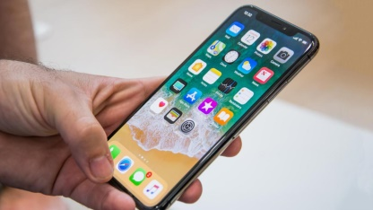
Three of the leading cable companies will continue to increase their profiles as wireless carriers this quarter after adding 574,000 lines of mobile service in the first three months of the year, says MoffettNathanson's Craig Moffett. Altice USA, Charter Communications and Comcast "have few subscribers to lose, and the industry's denominator will remain depressed, amplifying the relative gain," he says.
Light Reading 6.8.20
https://www.lightreading.com/cable-video/us-cables-disproportionate-mobile-share-gains-to-extend-into-q2---analyst-/d/d-id/761535
Image credit:
http://cdn1.expertreviews.co.uk/sites/expertreviews/files/2017/10/best_upcoming_phones_-_iphone_x.jpg

