"California Public Radio Day" Returns For Year 2
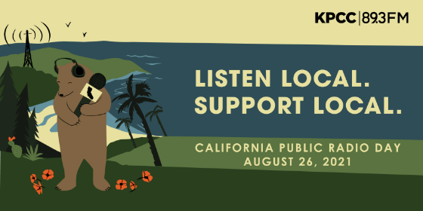
Organizers of last year's "California Public Radio Day" are bringing the event back for a second year in the hopes of raising further awareness -- and financial support -- for the state's publicly funded radio stations. This year's event, scheduled for Aug. 26, will see 30 stations participate in an effort to highlight the value of public broadcasting to the public.
Radio World 8.18.21
https://www.radioworld.com/news-and-business/headlines/aug-26-is-the-second-california-public-radio-day?utm_source=SmartBrief&utm_medium=email&utm_campaign=45863C53-9E40-4489-97A3-CC1A29EF491D&utm_content=0B0C3833-6033-4204-AF08-658E4010B85B&utm_term=a25693a1-51b6-4112-bde4-56bd420e983f
Image credit:
https://scpr.brightspotcdn.com/dims4/default/4f8d7f1/2147483647/strip/true/crop/3334x1668+0+0/resize/880x440!/quality/90/?url=http:%2F%2Fscpr-brightspot.s3.amazonaws.com%2Fa6%2Ff4%2F57b12e2f4907adddbebb6d56879a%2Fcprd-graphics-web-banner-800x400.png

