FCC's Carr Asks Lawmakers For TikTok Ban
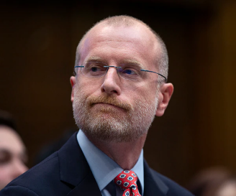
Federal Communications Commissioner Brendan Carr is asking the Committee on Foreign Investment in the United States for a ban on TikTok, citing concerns about how the platform's China-based owner ByteDance manages US data. The CFIUS is currently negotiating with ByteDance over a proposed deal in which it would transfer TikTok control to a US company.
Axios 11/2/22
https://www.axios.com/2022/11/01/interview-fcc-commissioner-says-government-should-ban-tiktok
Image credit:
https://www.newsmax.com/CMSPages/GetFile.aspx?guid=fec7dd6b-b5c7-48cd-8a7b-5c8f580cca71&SiteName=Newsmax&maxsidesize=600

