Cars, Drones, Homes Tap Into 5G
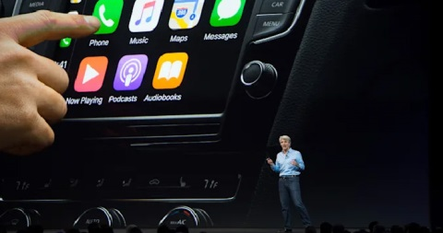
Enhanced vehicle maps and safety features, home broadband connectivity and drone deployments are the next frontiers of 5G technology, though all depend on network availability. Apple is reportedly expanding CarPlay features, several manufacturers are producing laptops with 5G support and Samsung is offering home routers for 5G wireless access.
BNN Bloomberg (Canada) 10/7/21
https://www.bnnbloomberg.ca/apple-s-plan-for-cars-using-iphone-to-control-a-c-seats-radio-1.1663072
Image credit:
https://techversions.com/wp-content/uploads/2021/10/Your-iPhone-Could-Eventually-Control-Your-Cars-Climate-And-Seats.jpg

